Benjamin Thompson, 1/12/13 Web Programing Fundamentals Problem Solving

Problem 1.

*A Cat, a Parrot, and a Bag of Seed:*

*A man finds himself on a riverbank with a cat, a parrot and a bag of seed. He needs to transport all three to the other side of the river in his boat. However, the boat has room for only the man himself and one other item (either the cat, parrot or seed). In his absence, the cat could eat the parrot, and the parrot would eat the bag of seed. Show how he can get all the passengers to the other side, without leaving the wrong ones alone together.*

1. Define the problem

The problem is the man needs to get to the opposite side of the river taking with him 3 things. The three things he has are: a cat, a parrot and a bag of seeds. He can only take one of these things with him at a time and needs to be careful what he leaves together so they do not get eaten.

If he leaves the cat with the bird it will be eaten, if he leaves the parrot with the seed it will also be eaten. One thing that is not clearly defined in the original explanation of the problem is the fact that you can take thing both ways as needed.

2. Break the problem apart

The big problems and constraints that I can see are that he can only take one thing with him at a time and that if he leaves some of the items alone they will be eaten.

The sub goals are

- To get to the other side of the river while keeping everything alive

- To not not leave the incorrect items with each other

3. Identify potential solutions

One solution is to leave the cat with and the seeds and cross the river with the parrot, leave the parrot on the opposite side of the river. Return and get the seed, take the seeds to the opposite side of the river and pick up the parrot. Take the parrot to the original side of the river and leave it while you pick up the cat and take it to the opposite side of the river. The final two steps would be to leave the cat with the seeds and return to the original side of the river to get the parrot and proceed to the opposite side of the river.

Another solution would be to change the cat and the seeds on the trips following trip one and two.

4. Evaluate each potential solution

Each solution does meet all goals and will work for all scenarios.

5. Choose a solution and develop a plan to implement it.

I have selected to go with my above-mentioned solution as shown below

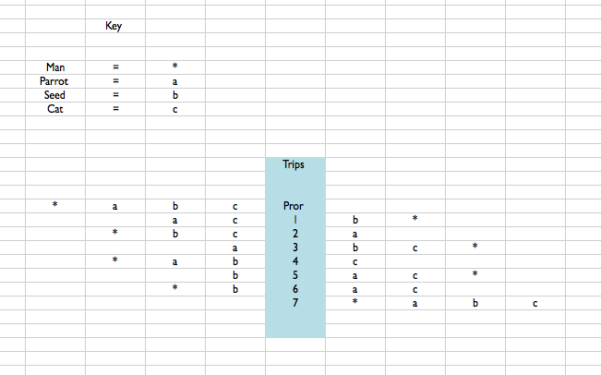

Problem 2.

*There are 20 socks in a drawer: 5 pairs of black socks, 3 pairs of brown and 2 pairs of white. You select the socks in the dark and can check them only after a selection has been made. What is the smallest number of socks you need to select to guarantee getting the following:*

*a) At least one matching pair*

*b) At least one matching pair of each color.*

1. Define the problem

The problem is, I need to discover how many socks I need in order to have the following

* At least one matching pair
* At least one matching pair of each color

I can do this only in the dark and can’t see what colors they are until I have selected them. I am starting with 20 socks. Which are 10 black, 6 brown, 4 white.

2. Break the problem apart

My biggest issue is that I cannot see the socks. Another challenge I face is the fact that the socks are not all the same color.

My sub goals are:

- To get a matching pair of socks

- To get a matching pair of each color of socks

3. Identify potential solutions

One possible solution is to get 5 socks. This will ensure that I have one pair of black socks. This is a relatively low number of socks, however it only solves the first challenge.

The solution to have a pair of all colors of socks would be to have 18 socks. This is the lowest number possible to guarantee that you have a pair of every color every time.

4. Evaluate each potential solution

Each solution would work for one of the goals. The second solution would be the best one because it would work for both situations.

Each of the solutions will work every time for the scenario it solves.

5. Choose a solution and develop a plan to implement it.

I will select the second plan. This will ensure that I have not only one pair but also one pair of every color.

The plan would be to select any of the 18 socks.

Problem 3.

*A little girl counts using the fingers of her left hand as follows: She starts by calling her thumb 1, the first finger 2, middle finder 3, ring finger 4, and little finger 5. Then she reverses direction, calling the ring finger 6, middle finger 7, first finger 8 and thumb 9, after which she calls her first finger 10 and so on. If she continues to count in this manner, on which finger will she stop?*

*a) What if the girl counts from 1 to 10*

*b) What if the girl counts from 1 to 100*

*c) What if the girl counts from 1 to 1000*

1. Define the problem

The problem is that I need to discover what finger the little girl will end up on when she is counting to 10, 100 and 1000. She counts to ten starting with her thumb as 1, her first finger 2, middle finder 3, ring finger 4, and little finger 5. She then reverses direction, calling her ring finger 6, middle finger 7, first finger 8 and thumb 9, after which she calls her first finger 10.

2. Break the problem apart

The first thing that I see is that the little girl counts in a very interesting pattern. It is not a consistent pattern from 1-10. Other then that the problem comes down to what is the finger that she lands on at every count of 10. In the instance it is her pointer.

Our sub goals are. I need to discover what finger she lands on for:

Count of 10

Count of 100

Count of 1000

3. Identify potential solutions

The solution is as follows. On every tenth count she is on her first finger. This means that since our problem is based on increments of 10 the answer is and always will be she is on her first finger!

4. Evaluate each potential solution

Each solution meets the goals every time.